The whole design of robot head is divided into two main parts: intelligent control system which belongs to the software work; humanoid structure and motor control system which belong to the mechanical work. Intelligent control system is the soul of the robot, which makes robot create humanoid emotion. Mechanical structure is the emotional carrier, which could change emotional information to action command.
4.1. Intelligent Control System

If a robot wants to show its own feelings in a moment, it needs to analyze not only the external environment and its own emotional state, but also signal of human language, body movements, and facial expressions and this requires modeling of the emotional state of the robot. As shown in Figures 2 and 3, we devise the control architecture of robot head, use computer vision and sensors to get information from human, and send it to three databases. After operation processing, the system could make decisions and generate homologous orders; finally we use FACS and emotional speech synthesis to show us humanoid feelings.
4.2. Mechanical Structure [14–16]

A robot with artificial emotion needs to be able to carry out a series of facial expressions and body language gestures, and facial expressions are more important and attractive to people, so the head design of humanoid expression robot is a key part. Robots obtain and analyze information, make comprehensive decisions, and finally realize their inner emotional states through the head expression, such as showing a smiling, upset, happy, or scared expression. Through taking advantage of the electronic and mechanical technology more harmony and unity, finally people can make the natural flow of emotional communication with robots.

As shown in Figure 4, the mechanical design of the robot facial expressions is based on FACS, and steering gears drive the emotional robot head; the synthesis of each feature point movement forms the robot’s facial expression. For example, when people expressed surprise, the eyebrows lift and bend higher and eyebrow skin will be stretched. When eyes are wide open, upper eyelid will be pushed up, but when the chin of the face falls, mouth will open. If the head of the emotional robot design is consistent with this, you will get a surprised face. We design the whole framework of robot head, which gives us a blueprint of robot head, so we can make it step by step. From the blueprint to real, we need three steps.
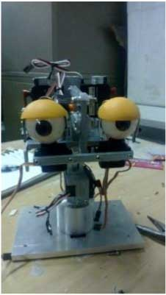
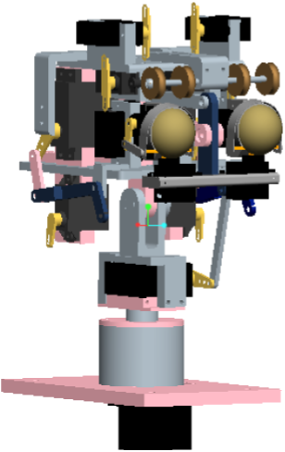

2->
Sensors
Sensors are devices used to capture information about the physical environment. The importance of such devices in robotics is not negligible. They play a fundamental role in the performance of a robotic system. According to the type of measurement information that they give us as output, they can be classified as proprioceptive and exteroceptive sensors.
Proprioceptive Sensors
The proprioceptive system is one of the two sensory systems in the human body. It measures internal quantities such as the velocity of a limb joint, muscle extension and muscle tension etc. The proprioceptive sensors that are used in humanoid robots can be listed as follows: •Position sensors that indicate the actual position of the robot. •Velocity sensors to measure the speed of the robot •Accelerometers to measure the acceleration. •Tilt sensors to measure inclination. •Force sensors to measure contact force with environment. They are usually placed in robot’s hands and feet.
Exteroceptive Sensors
The other sensory system in the human body is the exteroceptive system. It reacts to the changes which result in physical contact of the environment and the human body. Temperature fluctuations in the ambient and deformation of the skin surface can be given as examples to such changes. The information taken by means of the exteroceptive sensory system is critical for the robot to establish interaction with the physical world. In humanoid robotics the following exteroceptive sensors are utilized. •Proximity sensors to measure the relative distance (range) between the sensor and objects. Sonars, infrared sensors or tactile sensors, capacitive or piezoresistive sensors
•Vision sensors to recognize objects and determine their properties. CCD cameras commonly. •Sound sensors to hear what is spoken (e.g. microphones).

